NAME: M. CHATHURYA

TRAINER NAME: HARSHEE PITRODA

COURSE: PYTHON AND ML

DATE:6-6-2022

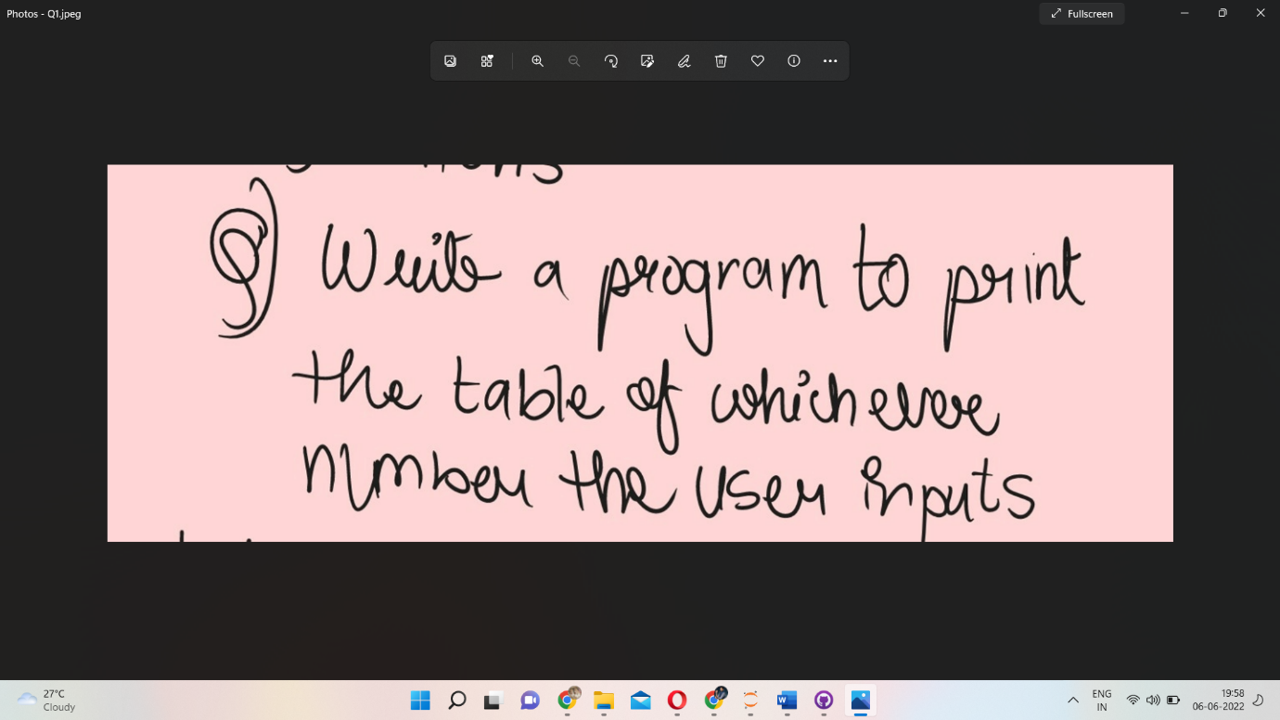

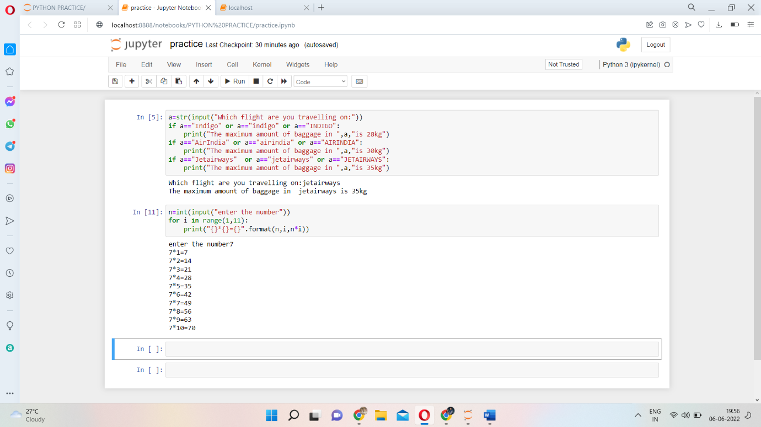

<https://www.hackerrank.com/challenges/python-loops/problem>

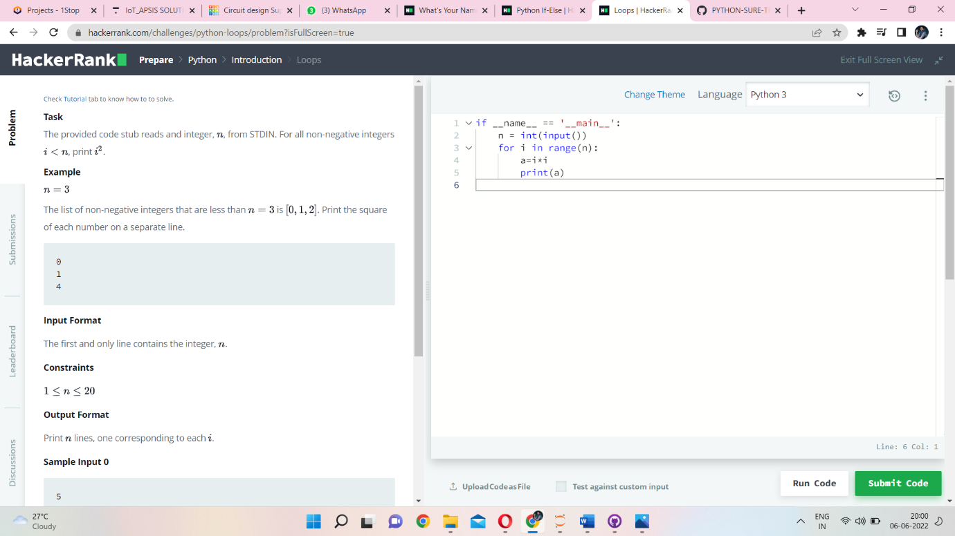

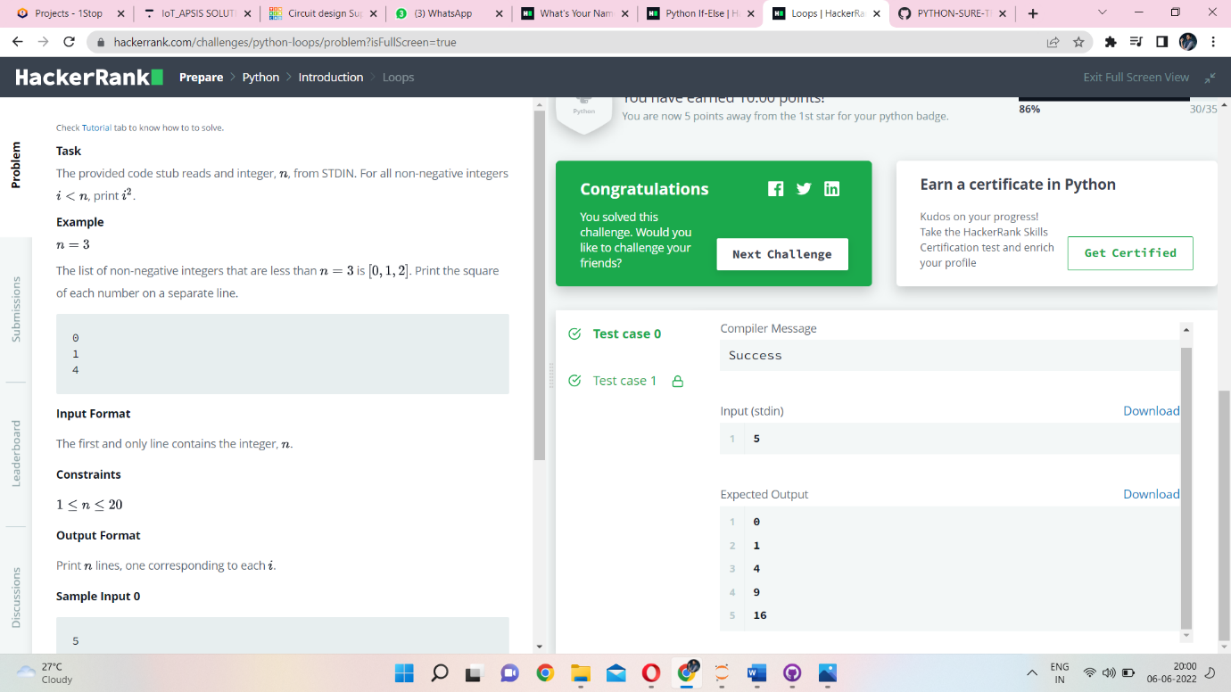

<https://www.hackerrank.com/challenges/py-if-else/problem?isFullScreen=true>

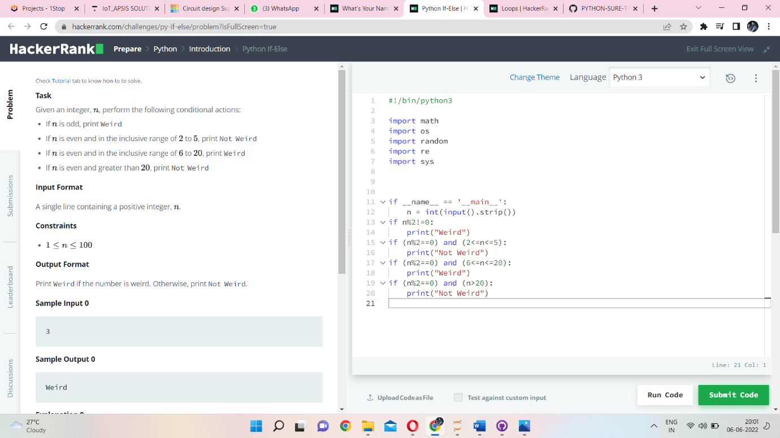

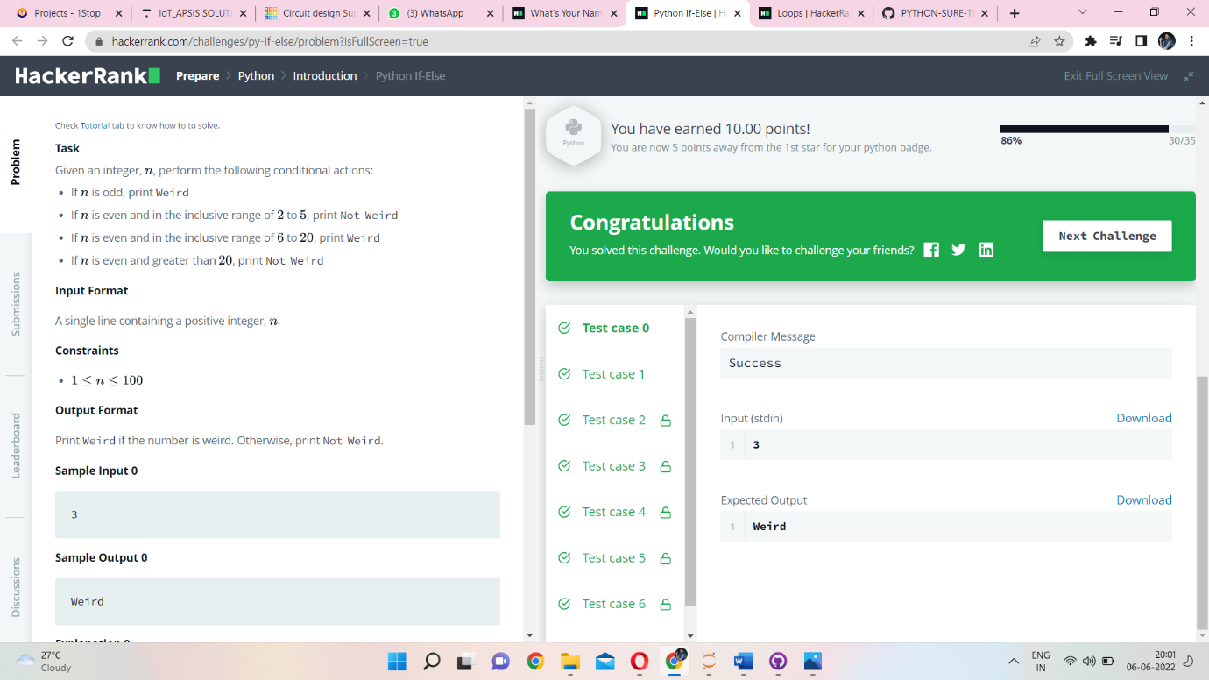

<https://www.hackerrank.com/challenges/whats-your-name/problem?isFullScreen=true>

